NATIONAL UNIVERSITY OF MODERN LANGUAGE ISLAMABAD
Lab: 01


Submitted to:
Ms Sana Ashraf
Submitted by:
Zulqarnain Hassan
Roll No: …………………… SP21379
Subject: …………………… UXD
Department: ……………… BSSE-6-Afternoon
Date: ………………………19/2/2025

Page 01

Design Sample screenshot
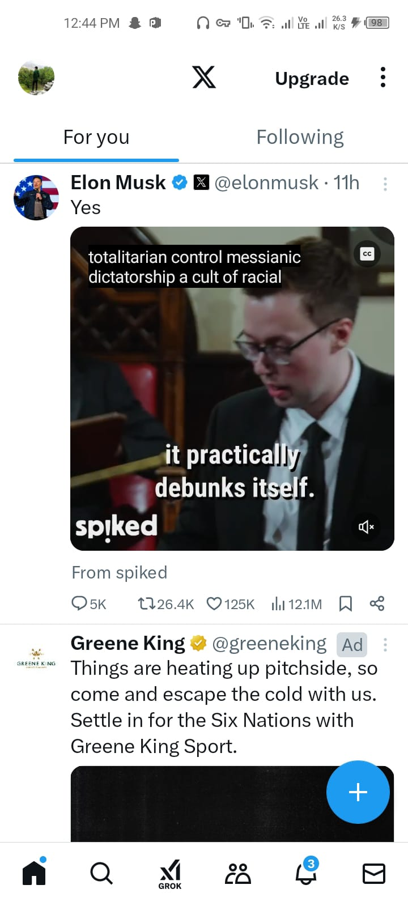
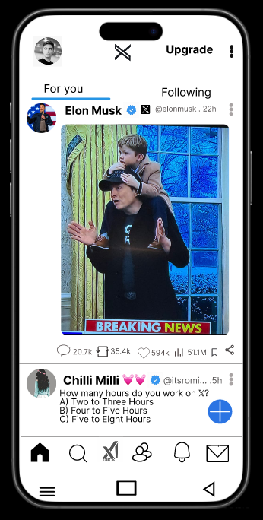

Page 2

Design Sample screenshot
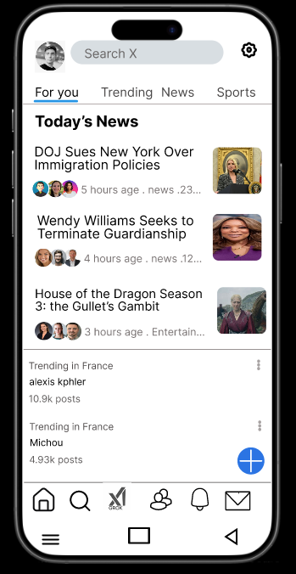


Page 3

Design Sample screenshot
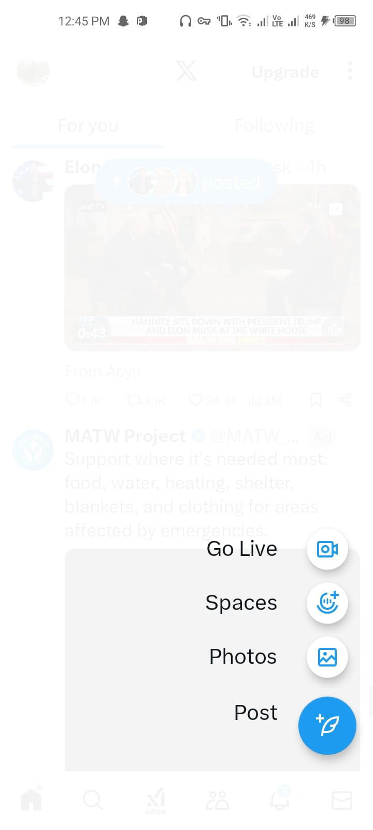
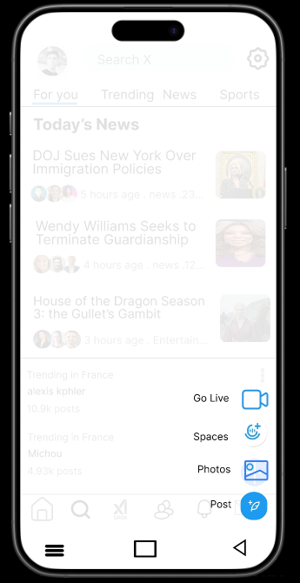

Wireframe
